GETTING STARTED
First Instructions for using Third Millennium online courses.

1. Registration
To make full use of the courses, you need to register for the whole site by creating a student account. Click on the link on the main home page, then follow the instructions.
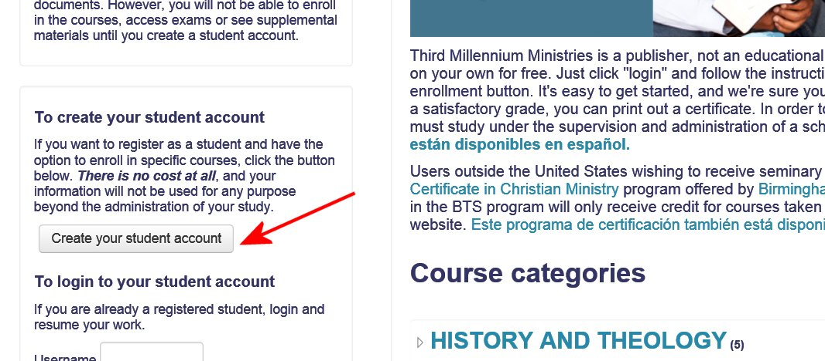

You just need to create your own username and password, then give some basic information: your email, first name, last name, city and country where you live. Then click on "Create my new account."
Write down your personal ID and password. Each time you open the site, you will need to login by giving this information.
This information will only be visible to the administrator of the site, not to other students.
Within a few minutes, you should receive an email to confirm your registration. Click on the hyperlink provided in the email.

2. Selecting a Course
We recommend that you save the main page of the site as a "favorite" so that you can find it quickly.
From the main home page, select a course. When you click on a category, ...
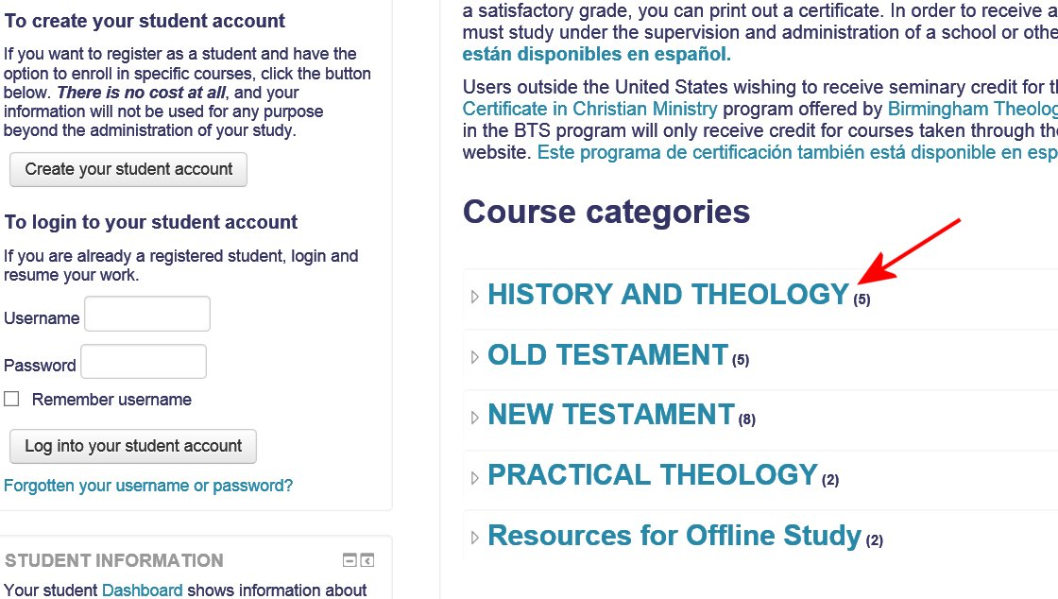

This opens a list of all the courses in that category, with a description for each one. To go to a course, click on the title.
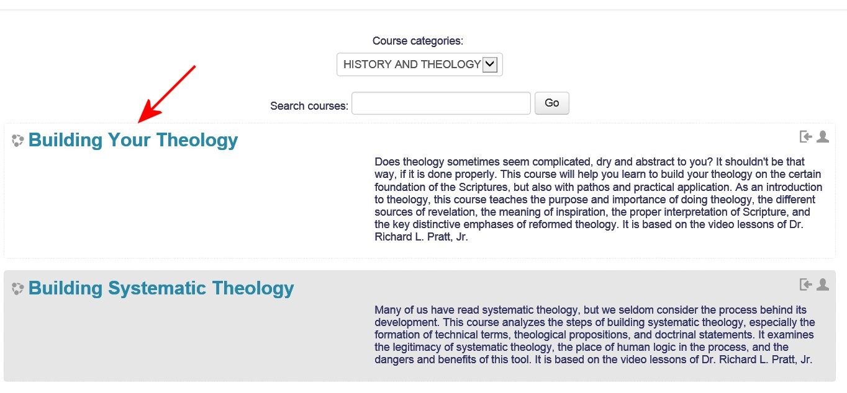

3. Enrolling in a Course
Once you register and choose a course, you need to enroll. Otherwise, you will be considered a "guest," and you will not be able to use some of the activities, such as quizzes and questionnaires. To enroll, just click on the link "Enrol me in this course."
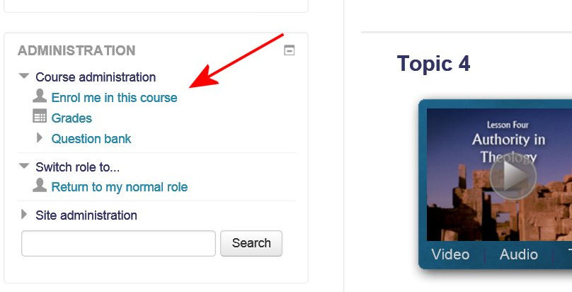

4. Starting a Course
To begin a course, click the "Start Here" button. This will open a page of basic instructions for the course.
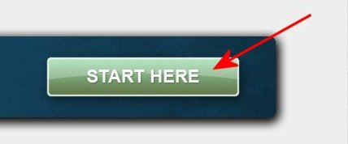

5. Tutorial: Navigating Through a Course
We highly recommend that you watch the video tutorial, "Navigating Through a Course," and that you read the PDF document by the same name. These tutorials explain how to use all the elements of the course.
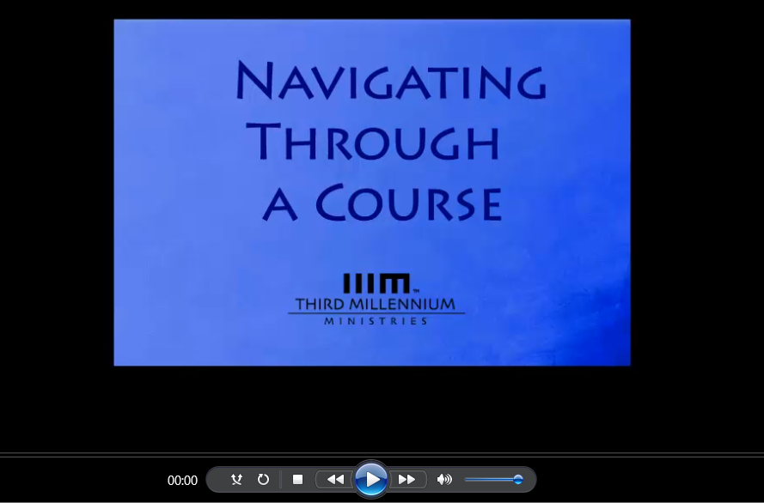

6. Web Browsers
Third Millennium courses should operate properly with various different browsers, including Explorer, Firefox, Google Chrome, and Safari.
However, some problems may occur with files such as PDF documents or videos in some versions of these browsers. We recommend always keeping your software updated with the latest versions, both of the browser and of Adobe Reader.

7. Lose Your Password?
If for some reason, you forget your password, you may click on "Forgotten your username or password?" below the login button. An email will be sent to you giving you instructions.
